ME302: 2025-26 - II
COURSE PROJECT [Total Marks = 15]
The course project is to be done in a group of maximum 3 members

A turbomachine component, which is being designed for a future gas turbine engine by company X, is to be tested at a smaller scale in a laboratory for performance analysis. The project is given to research laboratory Y, which has a closed loop testing facility for high pressure flows, shown below.

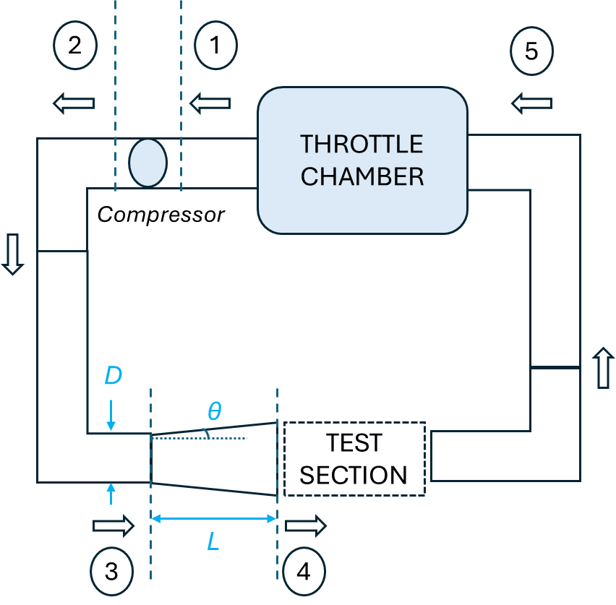

The flow is driven by a compressor and inlet stagnation pressure, p₀₁, can be controlled by the operator. The throttle chamber is positioned to reduce the end stagnation temperature and pressure to the inlet conditions. For testing an article in the facility, the test-section and the upstream diffuser are re-designed and fabricated. The inlet of the diffuser is shown as station 3 and the outlet is shown as station 4. The pipe diameter, D = 0.6 m, and the available length for diffuser, L = 1.5 m. The running facility has the following constraints:
- Minimum allowable pressure in any part of the facility = 200 kPa (structural requirement).
- p₀₅ >= p₀₁, else constant inlet conditions will not be maintained, and the closed-loop flow will not happen.
The length parameter of the actual prototype, l_prototype = 0.2 m. For the model to be representative of real conditions, the Mach number and Reynolds number are to be matched. The target engine conditions for the operation of the component are Mach number = 0.5 and Re (based on l) = 3.0*10^6. The company has left it to the laboratory researchers to select the geometric scaling for the model.

For experimental study, the larger the scale, the easier the instrumentation is. Defining scale = l_model/l_prototype:
- Find the maximum scale (between 0 and 1) which can be tested, meeting the requirements of the company and the constraints of the facility operation.
- Report the corresponding inlet stagnation pressure, p₀₁, and the compressor operating point.
- Indicate the compressor operating point on p₀ ratio vs mdot_ref curve.
Assume the facility to be adiabatic, which implies that the stagnation temperature remains constant at T₀₂ beyond station 2.

You may use the following data for your analysis:
- Consider test section inlet diameter, D₄, = 2*l_model (for sufficient gap)
- Compressor operation points are tabulated in a file and both .txt and .xlsx files are provided (mdot_ref = Mass flow rate at some reference condition, T0 ratio = T₀₂/T₀₁, p0 ratio = p₀₂/p₀₁)
- $Actual mass flow rate \left(mdot\right) = mdot_{ref}\left(\frac{p_{01}}{101.325 kPa}\right)\sqrt{\frac{293 K}{T_{01}}}$
- Inlet stagnation temperature is fixed at 293 K (T₀₁ = 293 K)
- Consider air as an ideal gas with R = 287 J/Kg.K , γ = 1.4 and speed of sound, $a=\sqrt{γRT}$. The viscosity value required for calculating the Reynolds number, $Re= {ρ_{4}C_{4}l_{model}}/{μ_{4}}$, can be assumed to be 1.83 x 10^-5 Pa-s.
- ∆p₀₂₃ = p₀₂ – p₀₃ = 1.5% of p₀₂
- For the diffuser, calculate the total pressure loss coefficient, $K= \frac{{Pt}_{3}-{Pt}_{4}}{\frac{1}{2}ρ_{3}{U_{3}}^{2}}$ using:
- K = 0 for semi-angle, θ < 0 (no loss for a nozzle)
- K = $3.2\tan^{1.25}{θ}{\left(1-\frac{{D_{3}}^{2}}{{D_{4}}^{2}}\right)}^{2}$, for semi-angle, θ > 0
- ∆p₀₄₅ = p₀₄ – p₀₅ = 5% of p₀₄

Expected documents for submission:
- Project report in pdf format
- MATLAB code/Python code/MS Excel files used

PS:
- The reports will be checked for originality using Turnitin, to ensure that no group has copied from each other.
- The MATLAB code/Python code/MS Excel files will be executed by the TA’s to check if the code is working
- 3 bonus marks will be awarded for early project submission (by 21st March)

